**Lab manual 13!**

**pointers**

**Learning Objectives:**

The objective of this exercise is to make you familiar with the concept of pointers and how to create, initialize and use pointers in C++.

**Task 1:**

Write a C++ program that input two numbers and performs basic arithmetic operations using pointers.

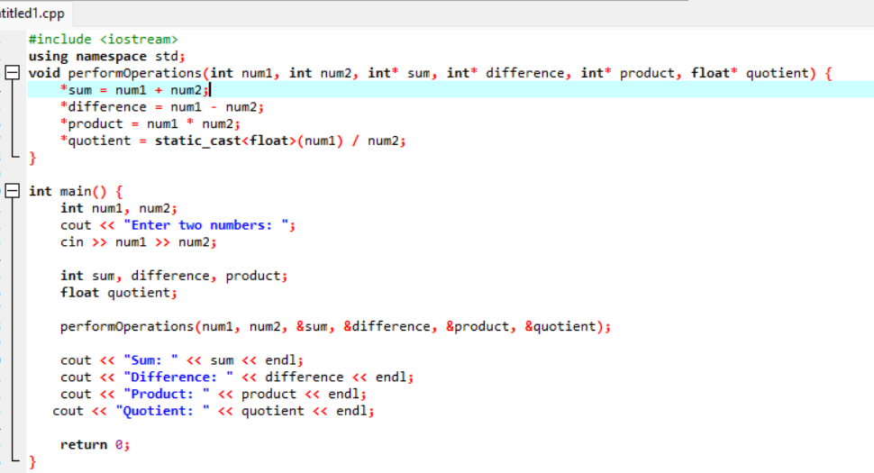 **Output:**

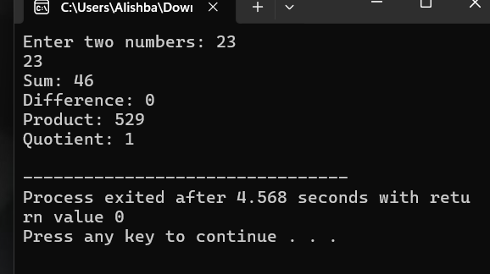

**Task 2:**

Write a C++ program to input and print array elements using pointer.

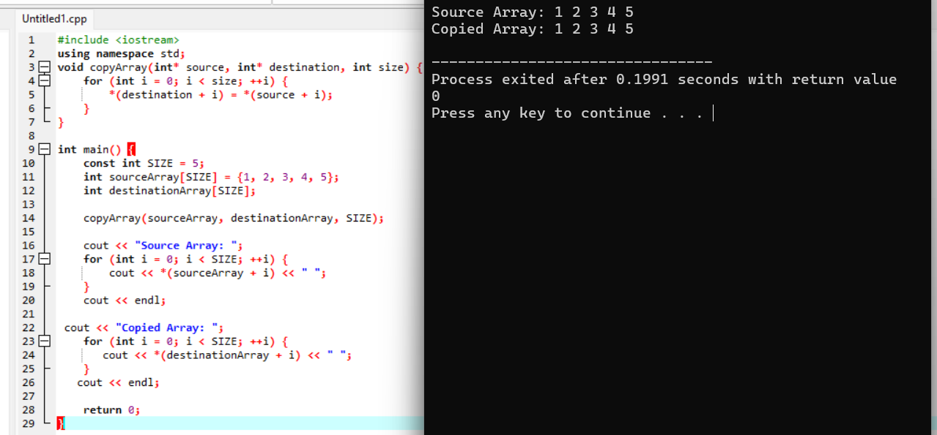

**Task 3:**

Write a C++ program to copy one array to another using pointers.

**Output**

